Electric Charges and Fields
1. Fundamentals of Electric Charge
Definition and Origin: Charge is an intrinsic property of matter that allows it to exert and experience Coulombian (electrical) forces. It is comparable to properties like refractive index or resistivity.

Properties of Charge:
☲ Scalar Nature/ Additivity of charge: Charges are added algebraically (q_{net} = q_1 + q_2 ...). Direction does not matter during addition (but sign does).

☲ Quantization: Charge exists only in discrete integral multiples of the elementary charge (Q = ±ne) rather that in continuous amount, where e ≈ 1.6 x 10^{-19} C.

☲ Transferability & Conservation of charge: Electrons can be transferred from one body to another, but they cannot be created or destroyed

☲ Association with Mass: Charge cannot exist without mass. Therefore, charging a body changes its mass: a negatively charged body becomes slightly heavier (gains electrons), and a positively charged body becomes lighter (loses electrons).

☲ Invariance: Unlike mass, length, or time, the magnitude of a charge is invariant—it does not change even if the charge moves at speeds approaching the speed of light.

Charging Mechanism: A body is neutral if it contains equal amounts of positive and negative charges, not zero charge. Charging occurs by disturbing this neutrality through the transfer of electrons.
☲ Positive Charge: An electron deficiency (losing electrons).
☲ Negative Charge: An electron excess (gaining electrons).

# Work function of a body : It is the amount of work to be done on a object in order to remove an electron from it's surface.

II. Methods of Charging
1. Friction (Rubbing): Physical contact and rubbing transfer electrons. This method is effective for both insulators and conductors.
# If objects A and B are rubbed the one with lower work function will get positively charged and other will get equal but opposite, negatively charged.

2. Induction: Charging without physical contact. A charged rod brought near a conductor causes polarization (redistribution of internal charges).
# works only for conductors and requires earthing
If a positive body is earthed, electrons flow from Earth to the body; if negative, electrons flow from the body to Earth.

3. Conduction (Contact): Charging by touching. For identical conductors, the total charge is shared equally: Q_{final} = (q_1 + q_2) / 2.
# charge distribution till potential of both body same.

III. Coulomb’s Law and Interactions
* The Law: The force between two "point” charges is directly proportional to the product of charges and inversely proportional to the square of the distance between them.
F = k(q_1)(q_2)/(r^2).
# Point Charge Definition: Applicable when the dimensions of the charged bodies are negligible compared to the distance between them.
# Coulomb's law is not applicable for distances < 10^-15 m.
# Follow Newton's third law.
# The force acts along the line joining the two charges, (central force)
# Electrostatic force is a conservative force.
* Medium Dependence: The force depends on the medium. In a medium with a dielectric constant (K), the force is reduced: F_{medium} = F_{vacuum} / K.

# K = εₘ/ε₀
# Water: Has a high dielectric constant (K ≈ 80), which is why it weakens ionic bonds (like NaCl) and acts as a universal solvent.
# Conductors: Have K = ∞. Consequently, the electrostatic force between charges inside a conductor is zero, a phenomenon known as electrostatic shielding.

# {
F{medium} / F{original} = 1/K
1 - (F{medium} / F{original} ) = 1- (1/K)
( F{original} - F{medium} )/ F{original} = ( K-1)/K
ΔF/F = {fractional change in force} = (K-1)/K
(ΔF/F)x100 = {percentage change in force} = [(K-1)/K] x 100
}

* Superposition Principle: The net force on a charge is the vector sum of individual forces from all other charges in the system.
# The force between two charges remains unaffected due to the presence of a third charge.
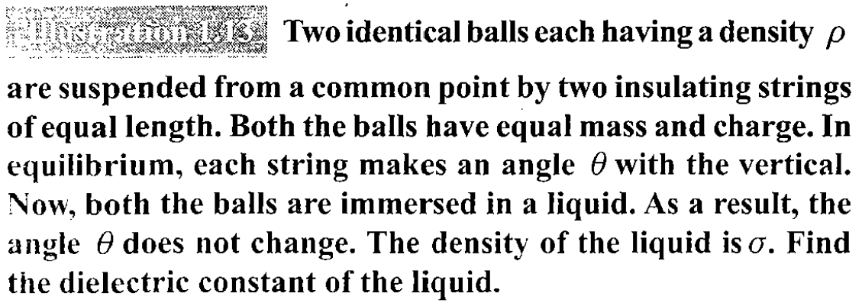#similar to a pyq

IV. Electric Field (EF) and Motion
* Definition: The 3D space around a charge where a test charge experiences force.
* Intensity (E): Defined as the force per unit positive (+1C) test charge
i.e. E = F/q₀.
☲ Direction: Points away from positive charges and towards negative charges.
* Motion in a Uniform Field: A charge q in field E experiences constant acceleration a = qE/m.
☲ This motion follows standard kinematic equations.
☲ If a charge is projected perpendicular to the field, it follows a parabolic trajectory similar to projectile motion under gravity.

V. Electric Field Lines
* Purpose: Imaginary lines used to represent the 3D electric field.
* Properties:
☲ Originate at positive and terminate at negative charges.
☲ Never form closed loops.
☲ Never intersect, as that would imply two directions of force at one point.
☲ Density: The closer the lines, the stronger the field.
☲ Inside Conductors: The field is zero; lines must terminate perpendicular to the conductor's surface.

VI. EF due to charge distribution

1. General Concepts and Densities
For continuous distributions, point-charge formulas are insufficient (Coulomb's law), and the field is calculated by integrating over elements. Three types of charge densities are utilized:
* Linear Charge Density ( λ ): Charge per unit length.
* Surface Charge Density ( σ ): Charge per unit area.
* Volume Charge Density ( ρ ): Charge per unit volume.

2. EF due to Linear Distributions (Wires and Rods)
☲ Finite Rod (on axis): The electric field at a distance x from the end of a rod of length L is E = kQ / [x(x+L)]
☲ Infinite Wire: The field is E = 2kλ/r where r is the perpendicular distance.
☲ Semi-infinite Wire: At a point perpendicular to the end of the wire, the field has two components, both equal to kλ/r (one perpendicular and one parallel to the wire).

Q = λ(πR)
☲ Angular Ring/Arc (at center): The field is E = (2kλ sin(θ/2)) / R where θ is the total angle of the arc. The direction is always along the angle bisector.
- Semi-circular Ring: At the center, E = 2kλ / R or E = 2kQ / [π(R²)]
- Quarter Ring: Or any other ring we can found it.
- For full ring: θ = π, E = 0, which follows the symmetry.
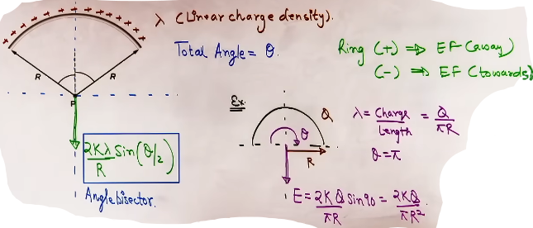
According to the sources, the electric field (EF) due to a charged thread or rod is calculated based on its linear charge density (λ) and the orientation of the point relative to its ends.

General Formulas for a Finite Thread
For a thread with linear charge density λ at a perpendicular distance r, where the ends of the thread make angles θ1 and θ2 with the vertical (perpendicular) line, the electric field has two components:
* Perpendicular Component : This component acts outward (for positive charges) and is given by:
E_perpendicular = (kλ/r)(sinθ₁ + sinθ₂)
* Parallel Component : This component acts along the direction of the wire (where the angle is greater) and is given by:
E_parallel = | (kλ/r)(cosθ₂ − cosθ₁) |

Effects of Symmetry
* Symmetrical Point: If a point is placed exactly opposite the center of the thread (where θ₁ = θ₂), the parallel components cancel out because cosθ₂ − cosθ₁ = 0. The net electric field in this case is purely perpendicular.
* Unsymmetrical Point: If the thread is not centered relative to the point, both E_perpendicular and E_parallel will exist, and the net field will be the vector sum of these two.
Cases
* 1: Infinite Wire: For an infinitely long wire, both angles θ₁ & θ₂ approach 90. In this case:
☲ E_parallel = 0.
☲ E_perp = 2kλ/r. {Same as from Gauss' law}
* Semi-Infinite Wire: For a wire that starts at a point perpendicular to the observer and extends to infinity in one direction, θ₁ = 0 & θ₂ = 90. In this case:
☲ E_perp = kλ/r .
☲ E_parallel = kλ/r .
☲ The net field acts at a 45 angle to the wire.

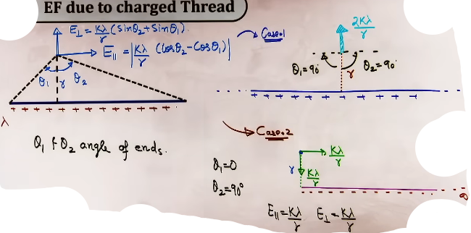
3. EF due to Circular Distributions (Ring on Axis)
For a ring with radius R and charge Q:
* On the Axis: At a distance x from the center, E = kQx/[(R^2+x^2)^{3/2}].
* At the Center: E = 0.
* Maximum Field:The field reaches its maximum magnitude at a distance x = R/√2

4. EF due to Surface Distributions (Sheets and Plates)
* Infinite Charged Sheet: The field is E = σ/2ε₀.
* Key Property: This field is uniform and independent of the distance r from the sheet.
* Multiple Parallel Sheets: The net field at any point is the vector sum of the fields produced by each individual sheet.
* Conducting Plates: When two or more plates are placed together, the outermost surfaces always carry half the total charge sum: Q{outer} = (sum Q)/2. Charges on facing internal surfaces are always equal and opposite.

5. EF due to Spherical Distributions
* Conducting or Hollow Sphere:
☲ Inside (r < R): E = 0.
☲ On Surface (r = R): E = kQ/(R^2).
☲ Outside (r > R): E = kQ/(r^2) (behaves like a point charge).
* Non-conducting (Solid) Sphere:
☲ Inside (r < R): The field is directly proportional to the distance from the center: E = kQr/(R^3) or E = ρr/3ε₀.
☲ Outside (r >= R): E = kQ/(r^2).

6. EF due to Cylindrical Distributions (Non-conducting)
* Inside (r < R): The field is E = ρr/2ε₀.
* Outside (r > R): The field is E = ρ(R^2)/2ε₀r.
VII. Electric Dipole
* Definition: A system of two equal and opposite charges (±q) separated by a small distance (2a).
# do se jyada charge ho sakte h tab total dipole moment nikalne k liye har dipole pair ka dipole moment nikalke un sab ka vector sum kar denge.

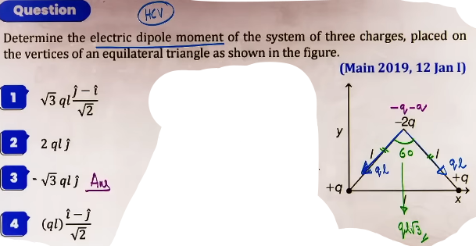
* Dipole Moment (p): A vector quantity p = q x 2a, directed from negative to positive.
* Field Intensity:
☲ Axial Point: E = 2kp/r³ . {E^ = p^}
☲ Equatorial Point: E = kp/r³ (directed anti-parallel to p: E^ = -p^).

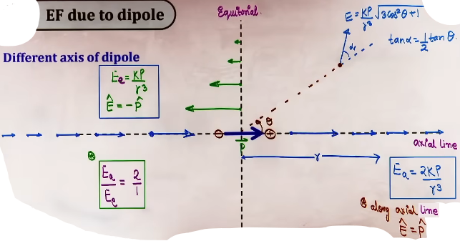
* Dipole in Uniform EF:
☲ Net Force: Always zero (F_net = 0).
☲ Torque: τ= p​×E = pEsinθ .
☲ If initial angle is θ₁ and final angle is θ₂, them work done in rotating dipole by this angle in uniform electric field is -
Work = PE( cosθ₁ - cosθ₂ ) .
# can be derived by Work done = change in potential energy
# or can be derived by integrating over dW = τdθ
☲ Potential Energy: U = −p​⋅E = −pEcosθ.
☲ Equilibrium: Stable at θ = 0 (minimum energy) and unstable at θ = 180 (maximum energy).
+------------+-----------------------+----------------+
| Term | Condition | Field behavior |
| ---------- | --------------------- | -------------- |
| Monopole | net charge ≠ 0 | E∝(1/r^2) |
| Dipole | net charge = 0, p ≠ 0 | E∝(1/r^3) |
| Quadrupole | both zero | E∝(1/r^4) |
+------------+-----------------------+----------------+
# if net dipole moment of the system is 0 {in quadrupole}

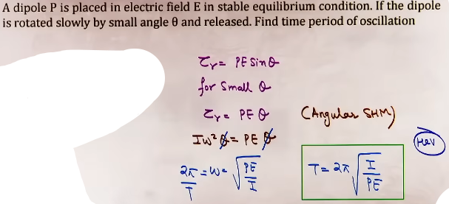

VIII. Electric Flux and Gauss Law
* Flux (Φₑ): The number of field lines passing perpendicularly through an area: Φ = E·A = EA cos θ.
☲ Positive Flux: Outgoing from a surface.
☲ Negative Flux: Entering a surface.
# Projection rule
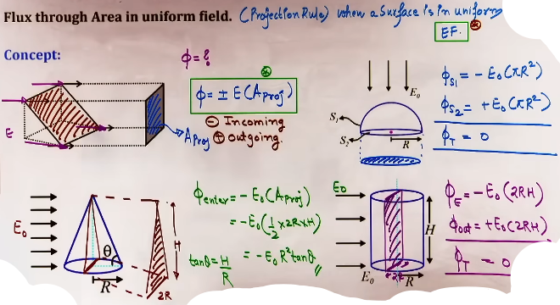
* Gauss Law: Total flux through a closed surface is 1/ε₀ times the net enclosed charge: Φₑ = Q₍in₎ / ε₀ .
* Mathematical Representation: The law is expressed as the surface integral of the electric field: Φ = ∮vec{E}⋅vec{A} = q_{in}/ε₀.
* Flux and Charge Sign:
☲ If the net enclosed charge is zero, the net flux is zero.
☲ If the net charge is positive, the flux is positive (outgoing).
☲ If the net charge is negative, the flux is negative (incoming).

* Important points -
☲ Charges located outside the Gaussian surface do not contribute to the net flux. This is because any field line from an external charge that enters the surface must also leave it, resulting in a net contribution of zero to the flux.
☲ Flux through any closed surface is dependent on inclosed charge only.
☲ The electric field (E) used in the Gauss Law formula at any specific point on the surface is the resultant field from all charges (both internal and external).
☲ Flux is independent of the shape or size of the Gaussian surface, it only depends on inclosed charge.
# Gaussian surface: An imaginary closed surface chosen using symmetry so that Gauss’s law can easily give the electric field (can technically be any random shape).

Major Applications (Electric Field Formulas)
Gauss' Law is used to derive the electric field (E) for various continuous charge distributions:
* Infinite Charged Wire: E = 2kλ/r.
* Infinite Thin Sheet: E = σ/2ε₀. This field is uniform and independent of the distance from the sheet.
* Conducting Shell/Hollow Sphere:
☲ Inside (r < R): E = 0.
☲ Outside (r >= R): E = kQ/(r^2).
* Non-conducting (Solid) Sphere:
☲ Inside (r < R): E = kQr/(R^3) or E = ρr/3ε₀
(field is directly proportional to distance r).
☲ Outside (r >= R): E = kQ/(r^2).
* Non-conducting Cylinder:
☲ Inside (r < R): E = ρr/2ε₀.
☲ Outside (r > R): E = ρ(R^2)/2ε₀r.
* Charged Ring (on axis): E = kqx/(R^2+x^2)^{3/2}. The field is zero at the center and reaches a maximum at x = R/√2.

